* Name**: Zohre Karimi**
* Picture:

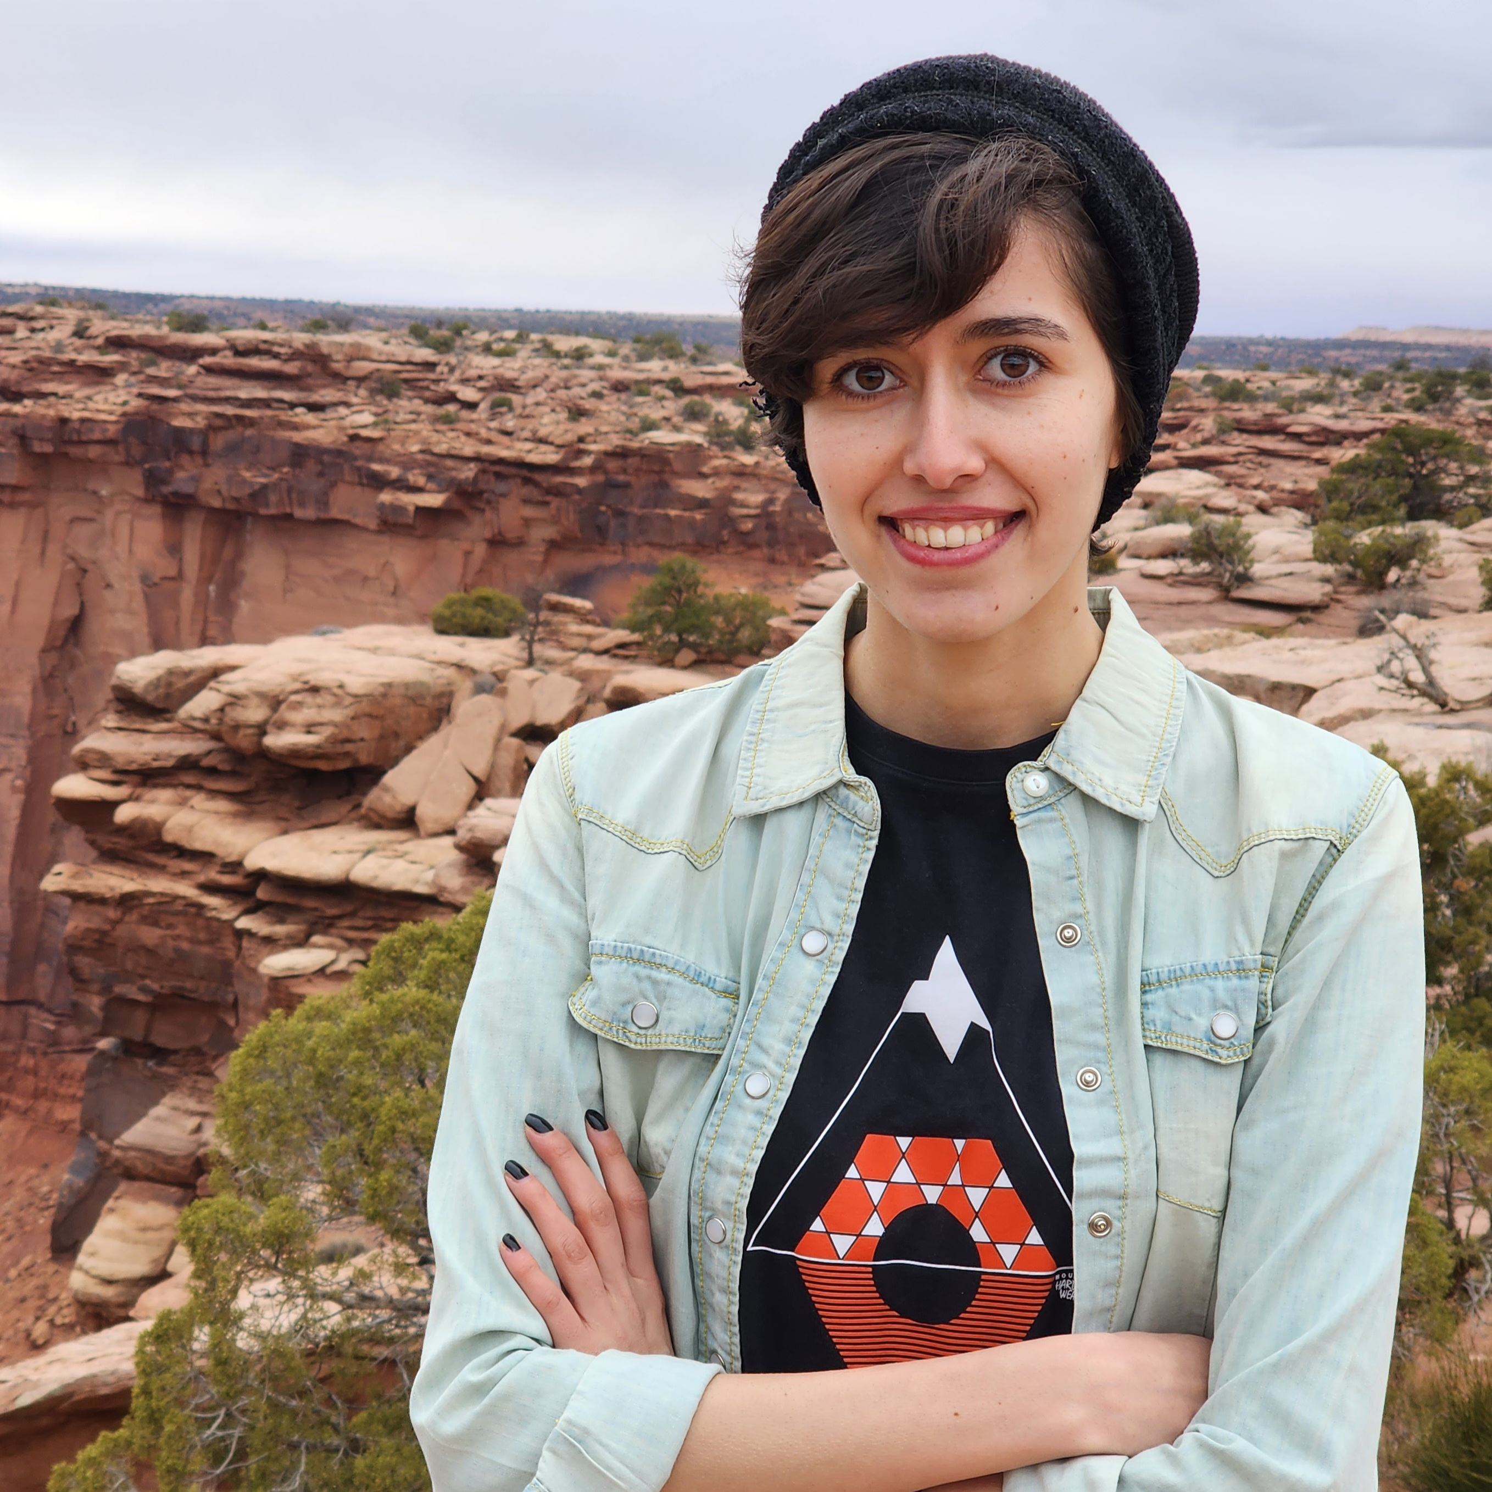

* Degreeand Department: PhD in Computer Science**.**
* About**:** I am a third-year Ph.D. student in Robotics at the Kahlert School of Computing, University of Utah, and a member of the Aligned, Robust, Interactive Autonomy (ARIA) laboratory, supervised by Dr. Daniel Brown. My research centers on Human-Robot Interaction and Surgical Robotics. To be more specific I am working on developing advanced reward learning techniques and imitation learning algorithms to enhance the capabilities of autonomous systems in surgical robotics. By integrating machine learning with robotics, I aim to improve precision, safety, and efficiency in robotic-assisted surgeries. In addition to this, I am engaged in projects exploring shared control between robots and humans, aiming to enhance collaborative interactions across various domains.
* Links**:**
  + Personal Website Link: <https://zohre-karimi.github.io/>
  + Google Scholar Link: <https://scholar.google.com/citations?user=v2ZkiuEAAAAJ&hl=en&oi=ao>
  + Personal Github Link: <https://github.com/zohre-karimi>
  + Linkedin: <https://www.linkedin.com/in/zohre-karimi-a79336172>

• Publications**:**

1. (Please list your publications here) –  
   Please add any related links and a picture/gif representing your work.

Name of paper:   
[Reward Learning from Suboptimal Demonstrations with Applications in Surgical Electrocautery](https://arxiv.org/abs/2404.07185)

* link to arXiv: <https://arxiv.org/abs/2404.07185>#
* link to paper: <https://ieeexplore.ieee.org/document/10585785>
* Pdf: <https://ieeexplore.ieee.org/stamp/stamp.jsp?tp=&arnumber=10585785>
* BibTex: @INPROCEEDINGS{10585785,

author={Karimi, Zohre and Ho, Shing-Hei and Thach, Bao and Kuntz, Alan and Brown, Daniel S.},

booktitle={2024 International Symposium on Medical Robotics (ISMR)},

title={Reward Learning from Suboptimal Demonstrations with Applications in Surgical Electrocautery},

year={2024},

volume={},

number={},

pages={1-7},

keywords={Point cloud compression;Medical robotics;Codes;Imitation learning;Decision making;Surgery;Reinforcement learning},

doi={10.1109/ISMR63436.2024.10585785}}

* website: <https://sites.google.com/view/lfdinelectrocautery>
* Picture:

